CHINA – EXPERIENCE THE LEGENDARY “MIDDLE KINGDOM”

Despite opening up its boundaries a great deal in recent years and welcoming increasing numbers of tourists ever deeper into its territory, for many people China remains one of the few remaining mystery destinations on the planet.
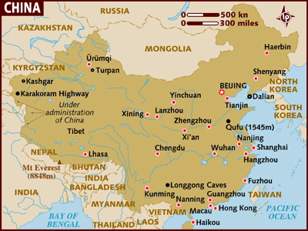

LOCATION :
THE PEOPLE'S REPUBLIC OF CHINA is the third largest country in the world in terms of area and the largest in terms of population. China has shared borders for centuries with Korea, the formerly Soviet Union, Afghanistan, Pakistan, India, Nepal, Sikkim, Bhutan, Burma, Laos and Vietnam.

VISA: The visa should be obtained prior to arrival in the country.

HOW TO GET THERE :
INTERNATIONAL AIRPORT: China is served by 4 International Airports, each of them at
Beijing – Beijing International Airport,
Shanghai – Pudong International Airport and Hongqiao International Airport and
Guangzhou-Baiyun International Airport

FLIGHTS INTO CHINA :
Cathay Pacific, Thai Airways, Malaysian Airlines, China Eastern, Air China and Air India are a few of carriers that fly between India and China.

DEPARTURE TAX :
When you depart China there is a 90 Yuan (around US$11) departure tax. Departure tax on all other domestic flights is 50 Yuan (around US$6). Fees must be paid in Chinese currency at a special airport tax desk before check in.

GETTING AROUND :
Flights Within China : All of China is linked by air.Though there are a number of Domestic Airlines, Air China and China Eastern Airlines are the 2 main airlines, which operate flights within internal cities in China.
Shanghai is less than two hours from Beijing. Shanghai is also a two-hour flight from Hong Kong. These three cities have connecting flights to small cities throughout China.

By Rail:
Travel by rail is an enjoyable, relaxing, and inexpensive way to see China's countryside. New or modernized equipment has replaced the old train systems in most areas. Travellers who lack the time to cover vast distances by train can still get a delightful taste of rail travel by journeying on popular short-distance routes. Some examples of travel time by train: 15 hours from Shanghai to Beijing, 2 hours from Shanghai to Hangzhou, and 45 minutes from Shanghai to Suzhou. A train from Hong Kong to Beijing takes 28 hours. A train from Xi'an to Beijing takes 14 hours. Normally, hotels provide the booking service for their guests.

By Bus:
Buses are now another excellent option. With the development over the last decade of a "National Highway system", luxurious coaches have become an increasingly popular mode of transportation for tourists.

By Taxi:
Taxis are available in all of China's major cities. Always carry your hotel card with you, and ask the hotel concierge to write down the address of your destination in Chinese characters.
Although in larger cities like Beijing, Shanghai and Guangzhou, English is widely spoken among the taxi drivers, many drivers in other cities may not understand English well.

CURRENCY :
China's currency is the Renminbi (RMB), usually called the Yuan. Ten Jiao make up one Yuan. The Bank of China has exchange desks for foreign currency and travellers cheques with convenient hours at all hotels, airports, Friendship Stores and others shopping areas. Visa, Master Card, American Express, Diner's Club, Federal Card, Million Card, and JCB credit cards are accepted at most hotels and state-run shops in the major cities. Some of the cards like Visa and American Express can be used to get cash advance in the main office of the Bank of China. Travellers are advised to pay in Yuan when shopping in smaller shops, at restaurants, and in smaller hotels

BUISNESS :
In China, businesses usually open from 8:00 am and close about 5:00 pm (Some cities may vary). Offices are closed for lunch break of one hour, generally between 12:00 noon to 1:00 pm.
Unlike western world, most Chinese supermarkets and department stores remain open on public holidays, and some of them even extend their working hours into late night.

CLIMATE :
While China is a year-round destination, the months of May, September, and October are ideal months for travel anywhere in the country. In the north, the winters are cold, and summers are warm, with moist monsoon air streams making it hot (80% of China's rainfall occurs between late May and early October, mostly in the Southern regions). June through August is a good time to visit central and northern China. Spring and autumn are the best months for travel in Southern China. The months of March and April is the shoulder season; while off-season is from from November through the winter months.

CITY | Jan | Feb | Mar | Apr | May | Jun | Jul | Aug | Sep | Oct | Nov | Dec
Beijing F | 28 | 32 | 40 | 60 | 75 | 78 | 80 | 76 | 68 | 55 | 40 | 36
C | 0 | 2 | 5 | 16 | 24 | 26 | 27 | 25 | 20 | 13 | 5 | 2
Shanghai F | 40 | 42 | 50 | 65 | 72 | 80 | 82 | 80 | 75 | 62 | 50 | 42
C | 5 | 6 | 10 | 19 | 22 | 27 | 28 | 27 | 24 | 17 | 10 | 6
Guangzhou F | 58 | 60 | 69 | 71 | 80 | 83 | 83 | 81 | 78 | 70 | 60 | 57
C | 15 | 16 | 21 | 22 | 27 | 28 | 28 | 27 | 24 | 17 | 10 | 6
Xi’an F | 32 | 38 | 50 | 56 | 72 | 80 | 78 | 76 | 60 | 52 | 40 | 30
C | 0 | 4 | 10 | 14 | 22 | 27 | 26 | 25 | 16 | 11 | 5 | -1
Kunming F | 50 | 52 | 58 | 65 | 68 | 68 | 70 | 67 | 65 | 62 | 55 | 50
C | 10 | 11 | 15 | 19 | 20 | 20 | 21 | 20 | 19 | 17 | 13 | 10
Lhasa F | 29 | 34 | 41 | 46 | 54 | 60 | 61 | 60 | 57 | 48 | 39 | 32
C | -1 | 1 | 5 | 8 | 12 | 16 | 16 | 16 | 14 | 9 | 4 | 0
Urumqi F | 5 | 10 | 32 | 50 | 66 | 74 | 78 | 74 | 64 | 47 | 28 | 10
C | -15 | -12 | 0 | 10 | 19 | 24 | 26 | 24 | 18 | 9 | -2 | -12
Guilin F | 47 | 48 | 56 | 65 | 74 | 79 | 83 | 82 | 78 | 69 | 59 | 50
C | 8 | 9 | 13 | 18 | 23 | 26 | 29 | 28 | 26 | 21 | 15 | 10

CLOTHING :
Pack lightly, and bring casual clothes. A sturdy, comfortable pair of walking shoes is a must.
Bring a couple of shirts, sweaters, and a jacket (depending on the season) that can be worn in layers to accommodate China's range of climates.

TIME :
China is 2 hours 30 minutes ahead of India

ELECTRICITY :
Electrical appliances will require an adapter that can change the shape of the plug prongs, as well as an electrical voltage converter that will allow a normal 110-volt American appliance to take 220 Volt Chinese current. Throughout China 220 volt is used, although 4 & 5-star hotels are wired for use of 110-volt electrical appliances.

INTERNATIONAL DIALLING CODE : + 86
LOCAL AREA CODES : | Beijing: 10, Shanghai: 21, Wuhan: 27, Xian: 29, Guangzhou: 20

TIPS :
Tipping is not customary in China, but visitors should be aware that local attitudes on tipping are changing, and vary with the occasion. Many tourists bring along inexpensive gifts to show their appreciation to guides, drivers or others who have been helpful

LANGUAGE :
Mandarin is commonly used in the modern China. It is one of the five working languages designated by the United Nations. The majority of the 55 other ethnic groups have their own languages. There are also many dialects around the country. English is spoken at most locations tourists are likely to visit, departure announcements and travel schedules are in English, and there are often separate ticket counters for foreigners.

INFORMATIVE WEBSITES :
www.cnto.org

CITIES :
BEIJING :
If you can choose to visit only one city in China, it definitely should be the capital city - Beijing. It boasts of so many best attractions, not only the 'Nation's Best' but the 'World's Best'.

Accomodation in Beijing :
There is plenty of accommodation in Beijing to suit all budgets and tastes.
A little further south, but still within walking distance of the centre is the Chongwen district where you will find a number of reasonably priced hotels including the very pleasant New World Courtyard, a modern, comfortable hotel a few minutes' walk from the main railway station with an indoor pool and gym.
Many of the best areas to look are just to the east or south of Tiananmen and the Forbidden City. Around the central business area of Jianguomennei, just east of Tiananmen, there are a number of medium to top-end hotels. The modern Novotel Xingiao is a reasonably priced option, with good facilities including a restaurant and spa. Alternatively try the New Otani Chang Fu Chong hotel, which offers stylish contemporary accommodation, with magnificent views over the city.
The busy shopping area of Wanfujing also has many hotels extremely conveniently located for central amenities.

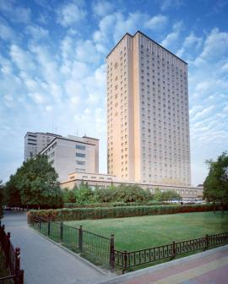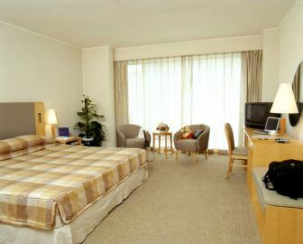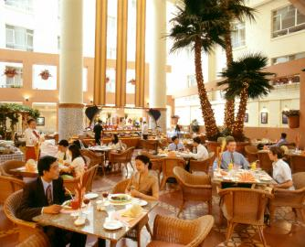
Must – Sees :
The Forbidden City :

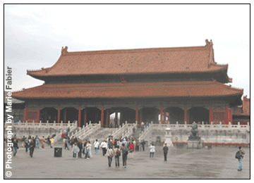

Central to both Beijing itself and to its history as capital of the Middle Kingdom, the majestic 600-year-old palatial grounds - home to 24 Ming and Qing Dynasty emperors - are suitably grand. The imposing pavilions, courtyards and exquisitely ornate buildings radiate imperial splendour. Over 900,000 cultural relics are housed in the palace museum alone. A day-long tour of the Forbidden City is an essential part of a visit to Beijing, and yields fascinating insights into the lives and daily rituals of the Mandarins.
*Large-scale renovation work on the Forbidden City is now taking place and is not expected to be complete until 2020. The site will remain open to visitors but some inconvenience may be caused.
Entrance from Tiananmen Square: Open: daily 08h30-17h00. Admission: CNY40 (Nov-Mar), CNY60 (Apr-Oct) per person.

Temple of Heaven :

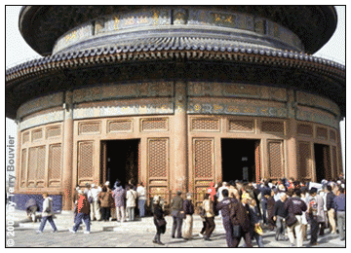

This striking piece of Ming Dynasty architecture - now a popular symbol for Beijing - was the site of the emperors' annual sacrificial rites offered to the gods in return for good harvests. Visit in the early morning when locals practise tai-chi among the trees; or be rewarded in the late afternoon with sounds of old folk tunes sung by Beijingers who gather there to enjoy the dusk.
*Renovation work on the Hall of Prayer for Good Harvest has finished, but follow up work is still underway and may therefore cause some inconvenience.
Entrance : Open: 06h00-21h00. Admission: CNY35 per person.

The Summer Palace :

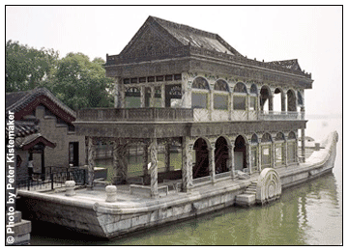

This Qing Dynasty imperial summer retreat is probably one of the most aesthetically pleasing historical sites in Beijing. There are several attractions here including the extravagant marble boat on the shore of Kunming Lake, built by the Empress Dowager Cixi, and the Pavilion of the Fragrance of Buddha, which affords marvellous views of Kunming Lake and the palace area. Boating and swimming in the lake are popular in summer, while skating is possible in winter.
Entrance : Open: daily 08h30-17h00. Admission: CNY50 per person.
Tiananmen Square :

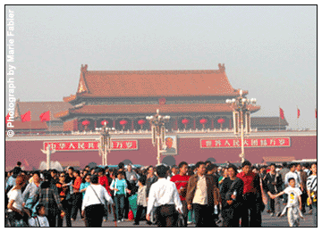

Of national symbolic significance, this huge square is presided over by the well-known and easily recognisable picture of Chairman Mao hanging on Tiananmen, the Gate of Heavenly Peace. Forever etched into the international psyche, the square was where Mao proclaimed the founding of The People's Republic of China in 1949.
The square lies directly south of the Forbidden City and north of Qianmen (the old Front Gate), a well-preserved and impressive remnant of the city's old fortifications. To get there, take the subway to the Tiananmen Dong (East) station.

Excursions :
The Great Wall of China :

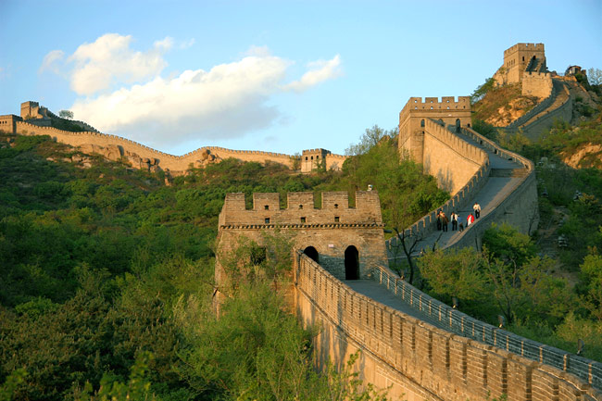

One of the greatest achievements ever undertaken by mankind at any time in history, the Great Wall of China has rightly become one of the world's most famous historical attractions. It is a truly amazing display of human endeavour, running for a total of 6,350km from east to west (though this includes sections that have collapsed and are no longer visible).
The most accessible places to see the Wall from Beijing are at Badaling or Mutianyu, which are easily reached in a day trip and it is one place where you can get the impression of what a formidable structure the wall really was in its day.
There are numerous companies offering coach trips to Badaling or Mutianyu, with prices from around CNY300 per person. If you want to visit the wall on own own then pick up a local mini-bus at Quianmen Station. For CNY50 per person these buses will take you to Badaling via the Ming Tombs and Juyongguan, from where you get a great view of the wall snaking over the valleys ahead. Be warned, the mini-bus round-trip takes around 10hrs, and doesn't include such things as air-conditioning or a tour guide that speaks your language.

Ming Tombs :

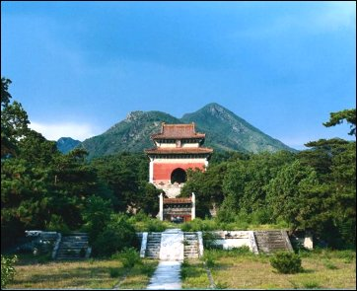

Easily combined with a day trip to see the Great Wall, the Ming Tombs 50km north-west of Beijing are a fascinating glimpse at the power and wealth of the Chinese dynasty that ruled the country in the Middle Ages. As significant culturally as the Great Pyramids of Egypt this complex is home to the tombs of no less than 13 of China's Ming Dynasty Emperors.
You have to pay for all elements of the complex, including to walk the Sacred Way. Prices per person vary between low (Nov-Mar) and high (Apr-Oct) season and are as follows: Sacred Way, CNY20/35; Dingling Tomb, CNY40/CNY60; Changling Tomb, CNY30/CNY45.

GUILIN :
Guilin is regarded in China as the country’s most picturesque city. The stunning landscape in which the city is situated has a kind of magic that is all its own. The strangely shaped hills, or karsts, with the verdant vegetation ranging from bamboo to conifers together with wonderful caves make Guilin such an attraction for tourists.
Guilin is considered to be the pearl of China's thriving tourist industry on account of the natural beauty and historic treasures.

Accomodation in Guilin :
Guilin is full of hotels, including the Sheraton on the Li River and the Bravo on Rong Lake in the centre of town. There are many quality hotels both near the Li River on Binjiang Lu and in the centre of the city on Zhongshan Lu. Most but not all will accept foreigners. Stay away from the area near the main train station, where it is noisy, crowded, and a bit more dangerous.
Always have a look at the room before making a decision.
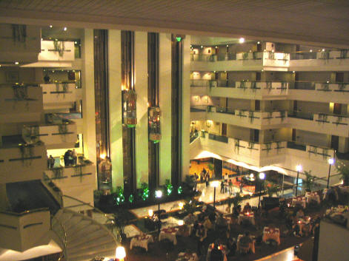

MUST SEES :

Reed Flute Cave :

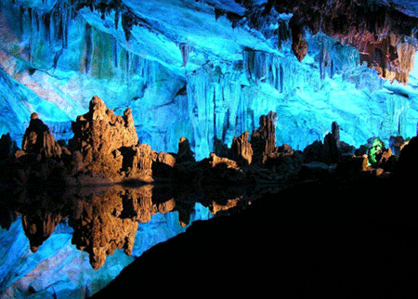

In the north-western edge of the city the Reed Flute Cave is undoubtedly one of the more remarkable of the region's many limestone caves. Half a kilometre of subterranean caverns can be toured, all filled with stalactites and stalagmites. Coloured lighting casts eery effects on the stone formations, reflected in the watery pools that fill much of the complex. It is possible to take a short boat-ride through part of the caves and there is even a tearoom and floating pavilion in the largest lake. The cave is named after the reeds that grow on the mountain side and that once hid the original tiny entrance from view. These thick grasses can be cut to make traditional wind instruments, and you can even buy some of the ancient "reed flutes" from the gift shop.
Admission: CNY60 per person.

Li River cruise :

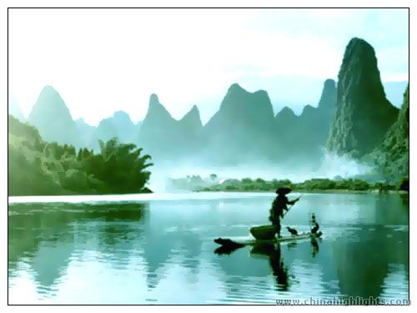

A half- or full-day boat ride down the Li River from Guilin is the reason for most people's visit to the city.For the 75km between Guilin and Yangshuo the river flows through some of the most spectacular limestone karst scenery found anywhere in the world. Massive pillars of forested rock rise on either side of the river and its tributaries, their sheer sides plunging right down to the water's edge. Many of the hills are named after their shape, thus you have Rooster Fighting Pagoda and the distinctive Elephant Trunk Hill along the river's edge. In Guilin you can buy boat tickets at the end of Nanhuan Lu near the river. Unfortunately for tourists, the local government has cracked down on illegal operators and charters are now quite expensive (up to CNY500).

KUNMING :
Kunming, capital of Yunnan Province, with a history of more than 2400 years, owes its importance to the fact that it was the gateway to the celebrated Silk Road.
Kunming enjoys a pleasant climate and does its best to live up to its title of 'the City of Eternal Spring'. Whenever you are planning to go, the temperature is always pleasant. With its convenient transport links in and out of the city, Kunming welcomes and sees off tens of thousands of tourists every day.

Accomodation in Kunming :
Kunming has a good range of accommodation, from basic to business-style accommodation with swimming pools and all the frills. As the city is fairly small, it's not difficult to find accommodation within easy walking distance of the central attractions and entertainment, though it's worth bearing in mind that many of Kunming's more interesting attractions are actually a bus ride out of the centre, so you may still need to rely on public transport (or taxis) to get around to a certain extent.

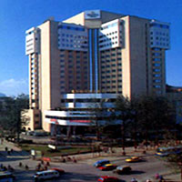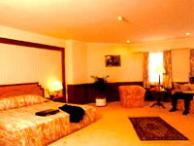
The massive Sakura has all the mod cons you'd expect and is popular with expat business people. Its location is ideal for eating and shopping - and there's a popular Thai Restaurant on one of the higher floors. In the evenings, the ground floor Jazz Bar offers a relaxing space with an excellent selection of cocktails and English-speaking entertainers. Tighter budgets might be better served with the comfortable Uchoice, still in the city centre if not quite to the same standard as the Kai Wah.

MUST SEES :
Daguan Park

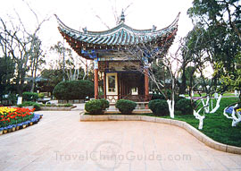
Perched south-west of the city centre on the northern tip of Lake Dian (Dianchi), this lovely old park (Daguan Gongyuan) is, for many, the epitome of Chinese classical beauty. Among the bamboo and plum blossoms, the 600-year-old park's centrepiece is the 17th-century pavilion, Daguan Lo. The structure is famously adorned with a 180-character-long couplet composed by the Qing Dynasty scholar Sun Ranweng (1700-1775), who was inspired by the lake's stunning beauty. As you wander around the park, you'll discover Chinese chess and card players sitting in
the shade while families eat picnics and fly kites nearby. The lake itself is as much a playground as it is a poet's inspiration. Speedboats whizz across the waters to the Western Hills on the opposite shore, shooting past the more leisurely longboats taking passengers on a relaxing tour of the lake. Open: 08h30-18h00. Admission to park: CNY10 per person. Charges for hiring boats vary.

Stone Forest

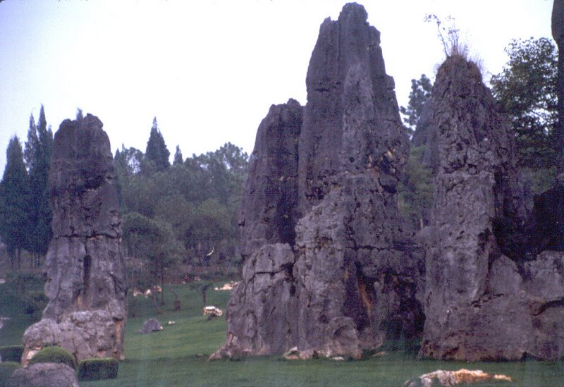

One of the more bizarre natural phenomena in the country, the soaring limestone peaks that make up the stone forest (Shilin) wouldn't look out of place in a sci-fi film. Centuries of erosion and splitting from rainwater have caused the grey rocks to form a mass of multi-formed pillars resembling huge fingers pointing up to the sky (or trees, if you prefer). Located around 80km east of town in Lunan County, it's a bit of a trek, but well worth it to see these unique geological formations. The area is also of interest to amateur anthropologists, as it is home to the Sani, an ethnically and culturally distinct people, who still practise their traditional way of life. They are particularly noted for their weaving skills, evidenced in their wonderfully colourful costumes. Since this is a major attraction, it's worth wandering a little off the beaten track away from the tour groups, where you'll find the real stone forest, quiet and wild. You can get there from Kunming by train, taking about 1hr30 mins, departing Kunming around 08h00 and returning around 14h00. There are numerous tour buses making the journey (taking around 2hrs) from hotels, which provide a convenient way of getting there. A better bet, if you can get a group of four or five together, is to hire a small van with a driver, costing around CNY200.

SHANGHAI :
Shanghai is situated on the estuary of Yangtze River of China.
Known as "the Oriental Paris", Shanghai is a shopper's paradise. Shanghai, a vigorous and energetic international metro-polis, welcomes people from all over the world to enjoy its special atmosphere. This modern metropolis with its rich heritage of ancient Chinese culture has much to see and do.

Accomodation in Shanghai :
From travellers' hostels to five star luxury hotels, there is accommodation in Shanghai to suit all budgets and tastes. Most of the large, international chains have hotels in the city, many of them with more than one branch.
You will find a number of hotels near Shanghai Central Station, obviously a good choice if you are planning to travel by rail to or from the city. The Liang An here is a large multi-storey hotel with an impressive façade and fountain frontispiece. Although it is far from the finest hotel in the city it is a good choice for anyone looking for reasonably priced accommodation and is certainly convenient for arriving in or leaving the city.
Elsewhere there are plenty of options in the Jing'an area and neighbouring Huangpu district, the prime areas for central attractions and entertainment. Next to the Bund you'll find some more European-looking hotels, relics of Shanghai's trading hey-day. Nowadays these are interspersed with some impressive modern buildings, catering to business travellers and tourists alike. The Yangtze is a large boutique hotel dating back to the 1930's with an impressive façade and conveniently located close to the Shanghai Museum and People's Square. All rooms were recently renovated to a high standard but it still remains a good choice for anyone seeking reasonably priced accommodation.
The modern development of Pudong has an increasing number of hotels, arguably the most impressive of which is the Oriental Riverside. Located just across the river from the Bund, the exterior of the hotel is an amazing space-age design, which fits in well with the ultra-modern architecture that surrounds it. Inside, it contains all the amenities you'd expect from a five-star hotel

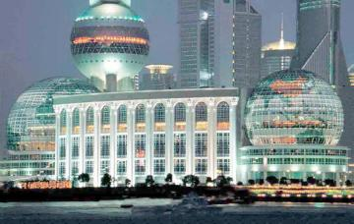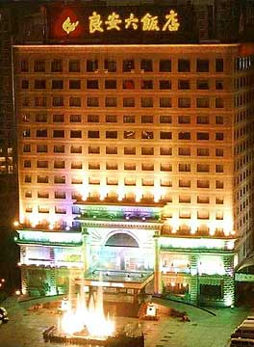

MUST SEES :

Walk the Bund :
One of Shanghai's most historical streets, the Bund (or Zhongshan Lu) stretches along the west bank of the Huangpu river, and has an air of space and freedom about it. The Bund gradually gained status as the "foreign street" of Shanghai where companies and consulates from all over the world set up shop, giving it a cosmopolitan atmosphere.The most amazing views of the skyscrapers of the modern Pudong district can be seen across the river, especially at night. For maximum enjoyment, take a ferry (Duration 10 minutes. Tickets: CNY0.50 per person. Nearest metro Lujiazui) from Pudong to the south end of the Bund, taking in the view first and then visiting some of the old buildings.
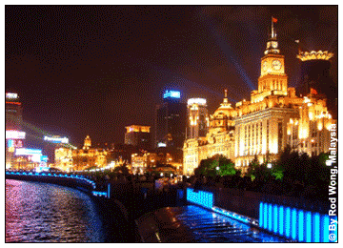

Jade Buddha Temple :

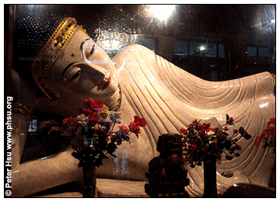

Arguably the most beautiful temple in Shanghai, the Jade Buddha Temple, or Yufo Si, is a Buddhist sanctuary, built in 1882 and still very much in use. The two Buddha statues brought from Burma for which the temple is famed - one seated, the other reclining - are quite stunning, made from an unusual, almost translucent white jade, giving them an appropriately other-worldly appearance.
Corner of Jiangning Lu and Anyuan Lu in north-west Shanghai. Nearest metro: Shanghai station (line 1 and Pearl line), about 1km away. Open: 08h00-17h00. Admission: CNY20.
Pudong Financial District :
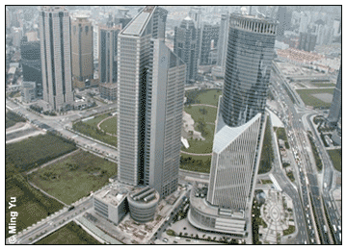
The showcase of Shanghai's modernisation drive, the Pudong district, just across the river from the Bund, is the holder of all the "tallest", "biggest" and "newest" titles in Shanghai. The area that has seen such rapid growth in recent years is now a serious high-rise mini-city. Its most famous building is the Pearl TV Tower, which, at 468m high, is the tallest television tower in Asia and offers superb panoramic views of the city from its observation deck.
Just nearby is the equally gargantuan Jin Mao building, a sleek, modern edifice using aspects of traditional Chinese design. Once the fourth highest building in the world it houses restaurants, bars and the Grand Hyatt Hotel as well as its own observation area.
Further out to the east is Century Park, Shanghai's largest open-space, made up of grasslands, forests and lakes. Take note that various activities often associated with trips to the park are prohibited, including playing football, flying kites, walking dogs, or being "improperly dressed" and offenders are reprimanded under the "Shanghai Environmental Sanitation Management ". You've been warned.
Pearl TV Tower: Open: daily 08h30-21h30. Tel: +86 (0)21-5879-1888. Admission: CNY50 (upper sphere); CNY100 space module. Century Park: Open: daily 07h00-18h00. Jin Mao building Open: daily 08h30-22h00. Admission: CNY50.
Yu Gardens :
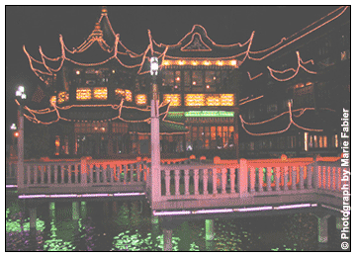

You can't miss the souvenir, jewellery and antique shops in the Yuyuan area of the city, which has a something of an old-world feel. And it's worth having some tea at the famous Huxinting Tea House nearby, overpriced but very atmospheric. The undoubted highlight of this part of town is the classical Qing Dynasty Yu Gardens with their pavilions and ponds linked by a maze of bridges, originally built between 1559 and 1577 for the Pan family, rich Ming Dynasty officials.
Yuyuan Shangcheng, Yuyuan Lu, South of the Bund close to the junction of Henan South Lu and Fangbang Central Lu. Gardens open: daily 08h30-16h30. Admission: CNY35. Tel: +86 (0)21-6328-3251.
Excursions :
Hangzhou :
Only a couple of hours from the bustling metropolis of Shanghai, but aeons away in atmosphere, the quiet, meandering lanes of Hangzhou are bound to refresh any jaded city dweller.
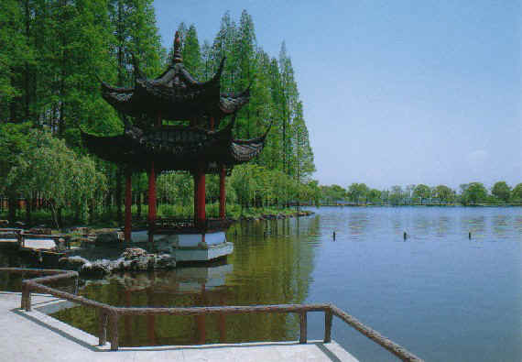
Stroll along the West Lake promenade, wander along the town's charming old streets, hike up the green rolling hills and spend hours relaxing in one of the many tea houses. Hangzhou is famous for its high quality green tea, Longjing, which you will see growing - and being drunk - wherever you go.
Regular express trains leave from Shanghai south railway station, and the ride takes two hours. Hard seat costs approximately CNY29 p.p. and soft seat CNY45 p.p.. Tour buses also make the trip starting at the Shanghai stadium, but are less comfortable and take longer to leave or enter Shanghai in rush hour traffic.

Suzhou : Lying on the edge of Lake Taihu, the beautiful 2,500 year old city of Suzhou is famed for its numerous stunning gardens and pavilions set amid winding canals. The delightful gardens are undoubtedly among the best in China. How could anyone resist visiting somewhere called the Lingering Garden or, better still, the Humble Administrator's Garden (honest!).
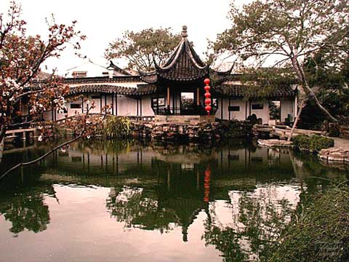
All designed in traditional style and many of them dating back to the 16th/17th centuries, these exquisite oases are home to little carved wooden bridges leading you over ponds, towering pavilions with latticed windows and bizarre manmade rock formations - all quintessentially Chinese.
Suzhou is around 500km from Shanghai and can be reached by train.
XIAN :
Xian, the eternal city, records the great changes of the Chinese nation just like a living history book. Called Chang'an in ancient times, Xian is one of the birthplaces of the ancient civilization in the Yellow River Basin area of the country. Xian is the capital of Shaanxi province, located in the southern part of the Guanzhong Plain. Except the colder winter, any season is relatively suitable for traveling.
Accomodation in Xian :
Xian is a well-established tourism destination and accommodation is plentiful and affordable. Locations within the City Walls command higher prices, with top international chains being found along Dong Dajie and similar main thoroughfares.
The Shangri La Golden Flower is a gleaming modern edifice perfectly located for sightseeing. Accommodation is luxurious and welcoming, with a number of restaurants and bars to dine in. Alternatively downtown you will find the equally impressive Aurum International, which stands adjacent to the Xian's New City Square and close to the Bell Tower.
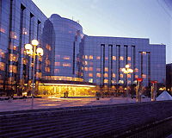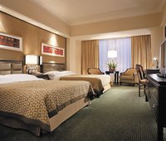

MUST SEES :
The Terracotta Warriors :
The Warriors were meticulously cast to be the personal army of Chinese Emperor Qin Shi Huang (c.246BC) in the afterlife. His colossal achievements (unifying calligraphy, laws, weights and measures, and incepting construction of the Great Wall) were achieved by ruthless tyranny, enslavement, and ruinous taxation. Hated by his subjects, he realised that his tomb's construction would require total secrecy. The thousands of craftsmen who had cast the warriors were rewarded by being buried alive - to silence them forever. However, even such extreme measures could not conceal details of the project totally, and within three years of completion, the complex had already been ransacked for the (very real) weapons in the arms of the statues, in a coup attempt by a former trusted General.
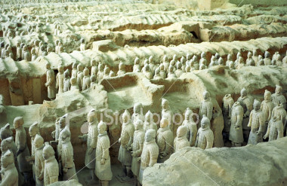
Minibuses (marked "Terracotta Warriors" in English) leave from the unofficial bus park in front of the railway station in Xian, or slower but frequent local buses 307 and 306 will get you there eventually. Exhibition complex open: 08h30-18h00. Admission p.p.: CNY90 (Mar-Nov); CNY65 (Dec-Feb).

Great Goose Pagoda :
The Great Goose Pagoda (Xiaozhai Dong Lu. Open: daily 08h00-18h00. Admission: CNY35p.p.) was a major centre of Buddhist worship in Imperial Xian - the origin of the name remains unexplained, as it does for the Small Goose Pagoda (Youyixi Lu. Open: daily 08h00-18h00. Admission: CNY10). Both were originally used for housing Buddhist manuscripts and can be ascended for views across the city. The Great Goose Pagoda is 4km south of the city and is often included in tours to the Terracotta Warriors; its smaller counterpart is just 1km south and thus more easily reached independently.
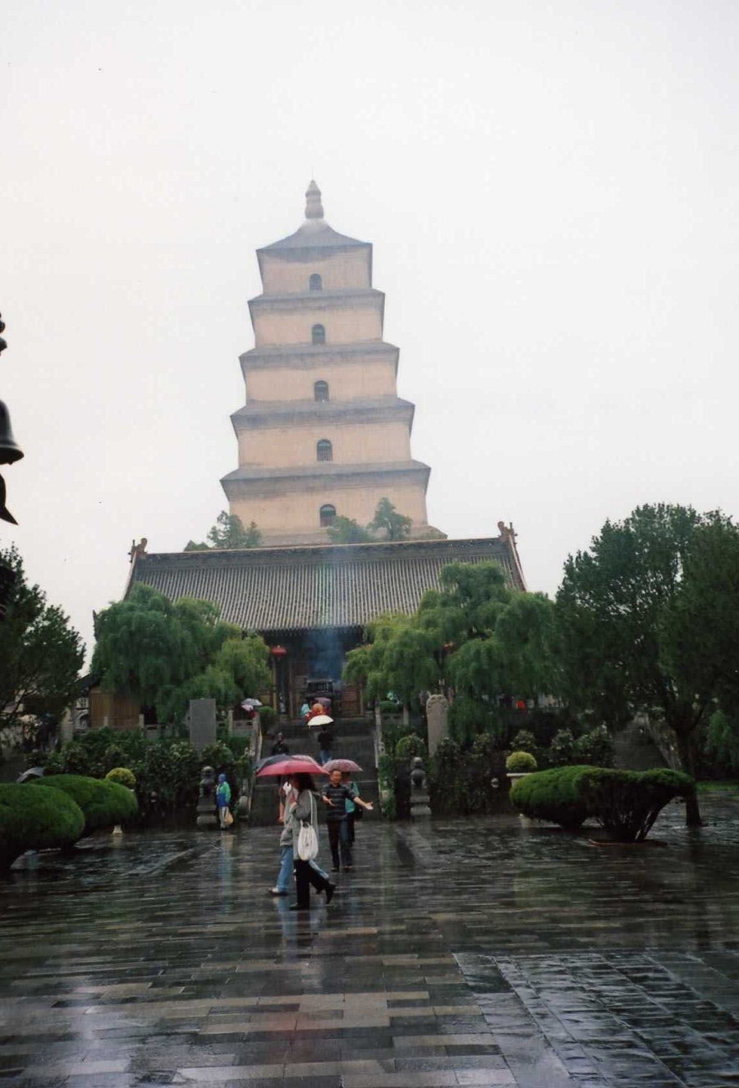

Drum Tower and Bell Tower :
Throughout the Empire, the working day would open with a bell carillon, and end on a drum-beat. Two great towers stand in the very centre of Xian to perform these timekeeping functions, the Bell Tower and the Drum Tower (Towers open: daily 08h30-17h30, admission: CNY20 p.p. each). The Bell Tower remains the central point of the city, and the focal point of the grid-system of roads.

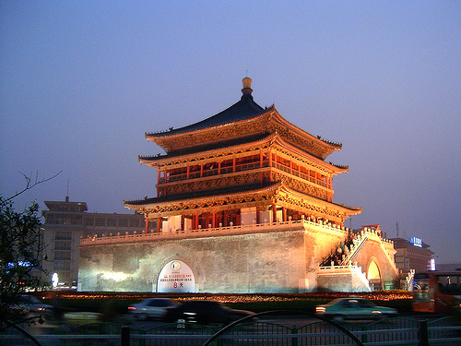

SHOPPING AND MUST-BUYS:
China is a shopper's delight. There is an incredible selection of boutique shops, department stores, and hotel shopping arcades to browse through. Or you can try bargain hunting at one of the new "free markets" that are springing up all over the country.
You're sure to be dazzled by the unique array of beautiful or practical gifts available in China, from high quality silks and porcelains to antique screens and traditional Chinese herbal medicines.
Throughout China, shops offer unique ceramics, paintings, stone rubbings, embroideries, carpets, furniture, jade carvings, custom-carved signature chopsticks, antiques, books, and much more. Shop personnel will often pack and arrange for shipping of bulky purchases back home.
Prices are usually clearly marked in stores and shops, and English is spoken in most tourist areas. Don't miss browsing through one of the state-run Friendship Stores; they are still considered as one of the best places to find an excellent selection of quality merchandise. One thing you must remember during your shopping is asking for the receipt.
Shops & Office Hours:
Businesses usually open from 8:00 to 8:30 am and close about 7:30 or 8:00 pm

INDIAN RESTAURANTS IN CHINA

CITY | RESTAURANT
Beijing | The Taj Pavilion Indian Restaurant  China World Trade Center, L-116 West Building,  #1 Jianguomenwai Dajie  Tel: (86-10)65055866/65052288 (Ext: 80116)  Fax: (86-10)65055866
Beijing | Tandoor Indian Cuisine  (Inside Zhaolong Hotel), #2 Gongti Beilu, Chaoyang District  Tel: (86-10)65972211 / (86-10) 65972299 (Ext: 2112)
Beijing | The Taj Pavilion  Holiday Inn Lido, Lido Place, Level-3,  Beside Bowling Alley, Jiachang Road, Jiang Tai Road.  Tel: (86-10)64367678/64376688  Fax: (86-10)65055866
Beijing | Spices  2/F New World Courtyard (near Marriott Beijing),  #3C Chongwenmen Wai Street, Chongwenmen District, Beijing  Tel: (86-10)67081188 (Ext: 2210)
Beijing | Omar Khayyam  1/F Chengyuan Plaza,  #9 Jianhua South Street (Opposite Friendship Store),  Jianguomenwai  Tel: (86-10)65675311/65675364
Beijing | Mirch Masala  Chaoyang Park, West Gate  Tel: (86-10)65915050
Shanghai | Red Chili  1413 Huai Hai Zhong Lu (near Fuxing Zhong Lu), Huaihai Zhong Lu  Tel: (86-21)64337799
Shanghai | Bombay Bistro  Shanghai Continental Hotel Gate 3-5, 418 Wu Yi Lu (near Ding Xi Lu)  Tel: (86-21)62106058
Shanghai | Indian Kitchen  #572, Yong Jia Road (between Yue Yang Lu & Ulumuqi Lu),  Xuhui District  Tel: (86-21)64731517
Shanghai | Bangra Bar  Golden Bridge Building A103104,  2077 Yan An Xi Lu (near Friendship Store, Hongqiao),  Changning District  Tel: (86-21)62757521
Shanghai | Hazara  59 Maoming Nan Lu, Jin Jiang Hotel, Maoming Lu  Tel: (86-21)64725494
Shanghai | Hazara  Bldg 4, Ruijin Guest House,  118 Ruijin Er Lu (between Yong Jia Lu & Fuxing Zhong Lu)  Luwan District  Tel: (86-21)64664328
Shanghai | Papadom Curry Restaurant  18 Dong Ping Lu (near Wulumuqi Zhong Lu) Hengshan Lu  Tel: (86-21)64331173
Shanghai | Spicy Cafe  1/F, Courtyard by Marriott Hotel Pudong,  838 Dong Fang Lu (near Weifang Lu)  Tel: (86-21)68867886
Shanghai | Muse Curry  151 Wan Ping Nan Lu (near Zhao Jia Bang Lu), Xuhui District  Tel: (86-21)64277738
Shanghai | Tandoor  Jin Jiang Hotel, Food Street, 59 Mao Ming road (S)  Tel: 86-21-64725494/62582582 (Ext: 9301)  Fax: 86-21-63281541
Shanghai | Karma  1111 Huai Hai Zhong Lu (near Fen Yang Lu)  Tel: (86-21)64270413
Guangzhou | Spice Island  807, Jiefang Bei Lu  Tel: 86-20-8364 3336
Guangzhou | Jewel of India  30, Tiyu Xi Lu,  Tianhe District  Tel: 86-20-8551 3882
Guangzhou | Maharaja Indian Kabab Corner  Shop No. S-217,  Shopping Arcade, 2/F,  China Hotel, Liu Hua Lu,  Tel: 86-20-8666 6888 (Ext: 2217)
Guangzhou | Natural Door Indian Chef  21, Yu Shan Lu, Beijing Lu,  Tel: 86-20-8319 7141
Guangzhou | Taste Of India  165, Tao Jin Road, Guangzhou, P.R.China.  Tel:86-20-83572688,83507688  Fax:86-20-83496610
Xian | Delhi Durbar  Near to Big Goose Pagoda, Xian  Tel : 86-29-85255157
Kunming | Bombay Curry House  400, Tuodong road, kunming, Yunnan 650011  Tel:86-871 310 4999

